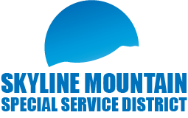
SMSSD Public Board Meeting
April 16th, 2024, 5:00pm to 8:30pm
Senior Citizens Center
101 East 100 North Mt. Pleasant. Utah 84647
Board Meeting
- Swearing in of Board Members
- Approval of meeting minutes
- Approval of financials
- Update on water system
- Update on State Reporting Required Documents
- Survey Employment & Payroll
- 2022 Financial Certification
- Water Quality (CCR) Report
- State Entity Registration
- Report from SMSSD/SMR Liaison
- New / Old Business
- Open time for customers on agenda
- Executive Meeting
- Adjourn
Join Zoom Meeting: Join Zoom Meeting: https://us06web.zoom.us/j/8018195705
One-tap mobile: +16694449171, 8018195705# | Phone: +1 669 900 6833 / Meeting ID: 801 819 5705

